[4:-4] (array([-19.20089042, 21.40595999]), array([[ 0.00429172, -0.0076924 ],

[-0.0076924 , 0.01379676]])) 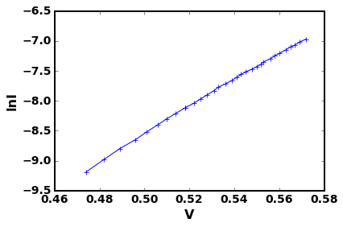

[5:-4] (array([-19.19072576, 21.38780827]), array([[ 0.00414456, -0.00742922],

[-0.00742922, 0.01332569]])) 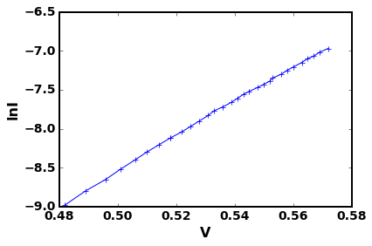

[6:-4] (array([-19.17981258, 21.36832385]), array([[ 0.00408649, -0.00732588],

[-0.00732588, 0.01314155]])) 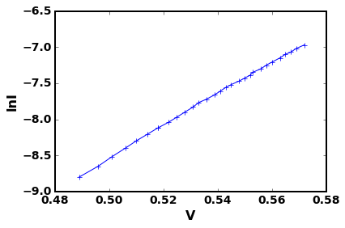

[7:-4] (array([-19.16567642, 21.34309985]), array([[ 0.00404294, -0.00724522],

[-0.00724522, 0.01299201]])) 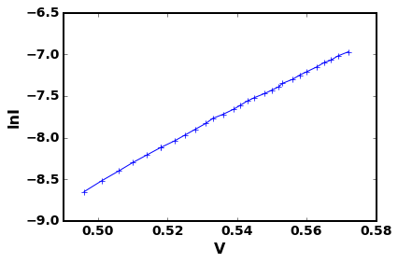

[8:-4] (array([-19.14842419, 21.31232636]), array([[ 0.00387558, -0.00694509],

[-0.00694509, 0.01245329]])) 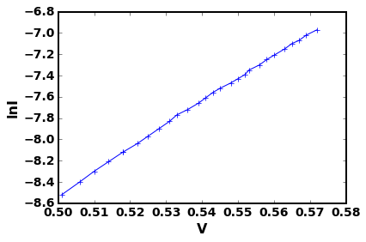

[9:-4] (array([-19.13382219, 21.28629938]), array([[ 0.00387756, -0.0069457 ],

[-0.0069457 , 0.01244889]])) 